**【Basic Info.】**



Name: **ZHANG MINGWEI**

IC/Passport No: **S7977757I**

Gender: **Male**

Birth: **21-July-1979**

Age: **38**

Nationality: **Singapore Citizen**

Race: **Chinese**

VISA IN USA: **H1B1**

**【Contacts.】**

Mobile: **65-97998378(Singapore)**

Email（Prefer）: [mwzhang@outlook.com](mailto:mwzhang@outlook.com)

Web Portal (Digital CV): <http://www.mwzhang.me>

Personal Blog (Tech Blog): <http://mwzhang.blogspot.com/>

Link In: linkedin.com/in/mingwei-zhang-b911b4107

**【Education.】**

**Year 2014 Bachelor Oxford Brookes University**

* BACHELOR OF SCIENCE (HONS) IN INFORMATION SYSTEMS AND SOFTWARE ENGINEERING;
* Grade B/2nd Class Upper;
* PHP, Linux, MySQL Coding Final year B2B/e-Bidding system independently;

**Year 2003 Diploma Singapore NanYang Polytechnic School**

* Diploma In Manufacturing Engineering
* Specialized in Automation System Design
* Nanyang Polytechnic Chinese Culture club
* Participate the Singapore Robotic Games (Y2003), independently working on Sumo Robot design

**【Professional Experience.】**

**Y2018 (Aug) – Now FTDI Singapore**



* **IT/SAP/BI Manager** (Lead 6 countries UK, US, CN, TW, SG, VN);
* Report to Engineering Director and COO Directly;
* Overall IT infrastructure & operation support;
* Overall system integration;
* SAP/BO system process;
* Business intelligent system design and setup (Reporting, Sales Report, Production Report, Inventory Report, Aging Report);
* SAP B1 integration with WMS, all B2B system;
* Product traceability system design(Warranty Card System) ;

**Y2017 (Apr) - Y2018 (Aug) Mentor Media USA (California)**



* **IT/Engineering Lead (Tech Lead);**
* 3PL Project (manufacturing in China and fulfill in USA , Provide System Integration with DHL or UPS/Support /Onboarding;
* Warehouse Management System Design, Testing & Implementation;
* HP Battery Recall Program (Process Map);
* Dell PPID and Media Support Process (Label Design, automation and all barcode related equipment setup);
* Amazon/shopify system integration with WMS (load order in WMS system using Python or Shell scripting);
* BOSE Refurbish / Testing system and Process design (Sound Testing Process design, label design, automation, testing script, Production line balancing, Time study);
* MS USB Cloning process (Linux Shell scripting);
* IT Security Audit from Microsoft and OEM, all passed successfully;
* Inventory Reporting (VBA report and MSSQL)
* AGV System research and design complete flow;
* Report to regional VP directly;

**Y2011 (Jul) - Y2017 (Feb) HP (Hewlett-Packard) Asia Singapore**

* **Manager II (SME in Customer Master Data);**
* PHP Design the partner/end customer setup system with database and reporting.
* Data scrubbing
* OTO, OTC(Opportunity To Order, Order To Cash);
* SAP Order Support, Scripting auto load order or batch update order information (VBS);
* Involve HP Split project, Project manager ;
* 6 month in Austin, HP and HPE sales process discussion, CRM , B2B and B2BI system testing sign off;

**Join HPE Singapore:**

* **Manager II (SME in B2B/B2Bi integration);**
* Focus B2B and B2Bi system integration (new customer onboard, customer like M1, Shell, Work with IT to make sure entire order flow pass through and Project sign off);
* Take lead to talk to customer understand customer system and provide solution (Project timeline, schedule and guide IT);
* Sales Process Map and training (HP B2B Portal, B2Bi Portal) ;
* All Green Belt Project;

**Y2003- Y211 (Jun) Mentor Media Singapore & China (Shanghai, Suzhou, Wuhan, Shenzhen, Chongqing, Tianjin, Yantai, Xiamen)**

* **IT/Process Engineer** ;
* Training in Singapore for Microsoft Licensing and HP CPMO project related
* Production system support (Shopfloor, ERP);
* IT System Analysis (SQL/VB system Order status, inventory query);
* SQL/VBA report Coding (inventory report, aging report, shipment report, backlog report,etc);
* Involve HR system IT project entire flow
* Coding& Support portal and ticketing system for CPMO project (24hours X7 Days)

**Year 2007 onwards:**

* **IT & Engineering Manager for great China;**
* New Branch Planning & Setup (Successfully setup the HP Xiyong processing zone);
* Involve HP Project bidding (IT system architect and budgeting);
* Work in Wuhan Foxcornn for Microsoft co-location project. Setup the MS licensing server and entire MS licensing printing equipment;
* Fast fulfillment IT system integration(4 hour TAT, 24hours X 7 days, no complain over 8 years);
* CTO type Inventory management (include the professional stock ticket) ;
* Intelligent Production Line Design (Vision System & Barcode scanning & auto weighing system );
* Warehouse Management (Deployment for Tianjin and Shenzhen, Basic pick and pack setup )
* Supplier and contractor management;
* Propose new tech or solution to management for cost saving;

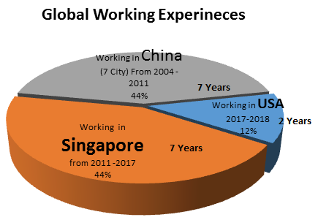

**【Data About ME.】**

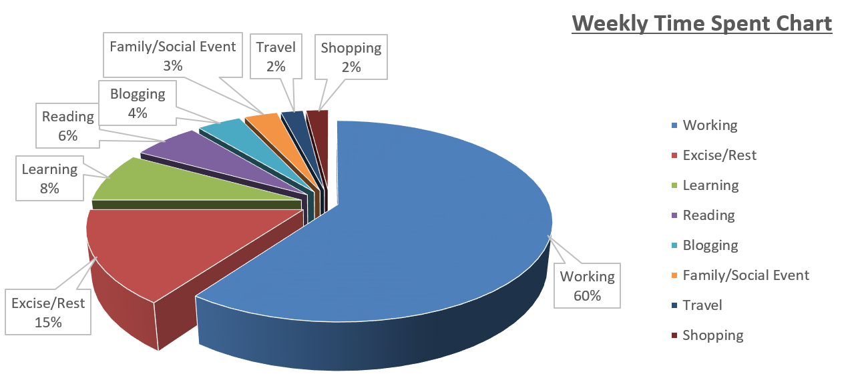

**Skillset Self-Evaluation**

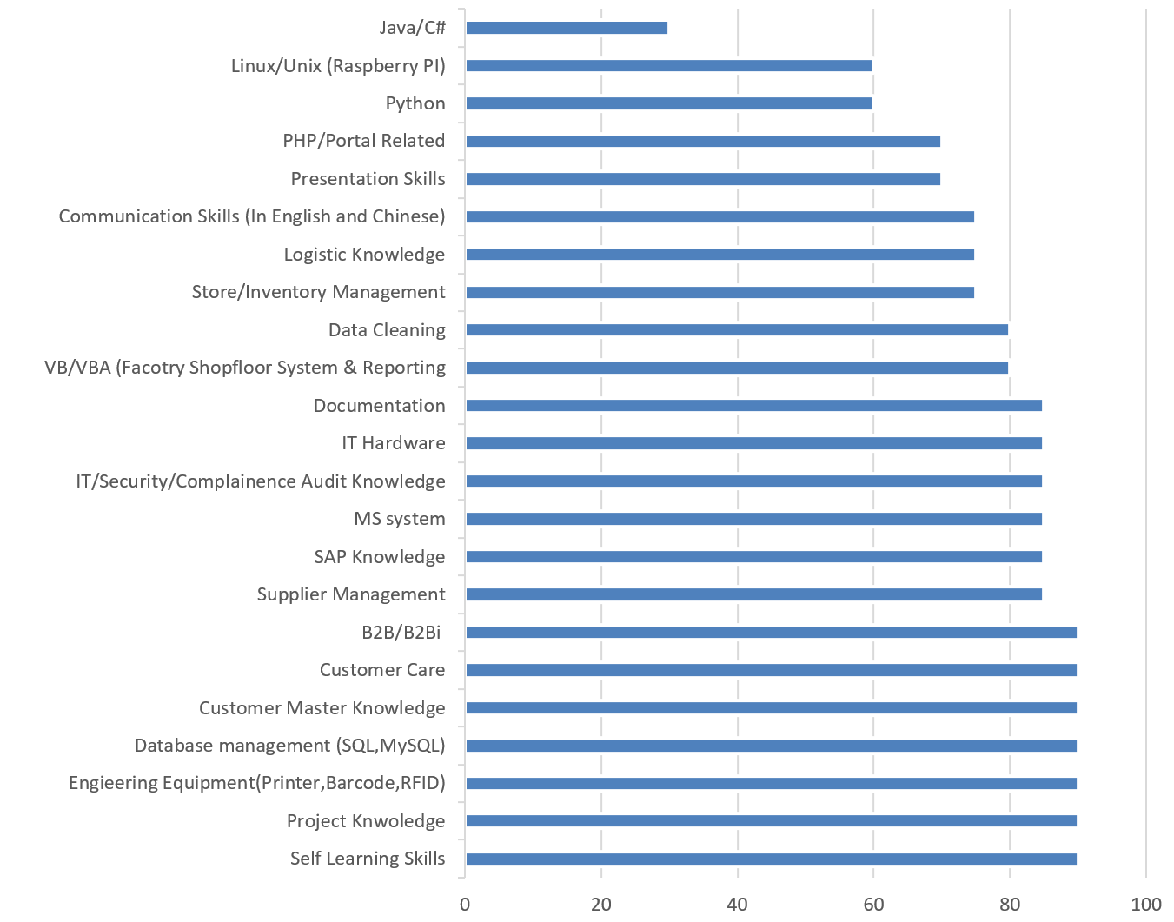

**Language Capability**

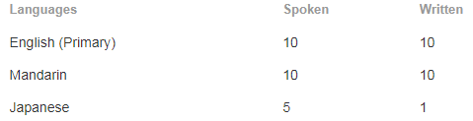

**【Reference URL.】**

* [MW.Zhang Photograph Work | 个人摄影作品集](http://photo.163.com/ilovezmw/#m=0&p=1)
  + http://photo.163.com/ilovezmw/#m=0&p=1
* [MW.Zhang LiveBand Performance | 本人乐队表演](http://www.youtube.com/watch?v=NTfeaQIyBzE)
  + http://www.youtube.com/watch?v=NTfeaQIyBzE
* [MW.Zhang Piano Clips | 钢琴练习片断](http://www.youtube.com/watch?v=jEQq_JFNVag)
  + http://www.youtube.com/watch?v=jEQq_JFNVag
* [Guitar Play | 吉他练习](https://sites.google.com/)
  + http://www.youtube.com/watch?v=wlrwLkPIYtQ
* [MW.Zhang Music Recording and Post Processing for my wife | 音乐后期录音处理](https://soundcloud.com/ming-wei-16/the_moon)
  + <https://soundcloud.com/ming-wei-16/the_moon>
* PHP Portal Design | PHP网站设计作品
  + [www.lillybellesg.com](http://www.lillybellesg.com)
  + [www.mybino.com](http://www.mybino.com)
* [Warehouse Management Automation System Design](https://youtu.be/xjmJFhwHv0k) |智能仓库设计
  + https://youtu.be/xjmJFhwHv0k

Personal IT knowledge Blog Since Year 2007

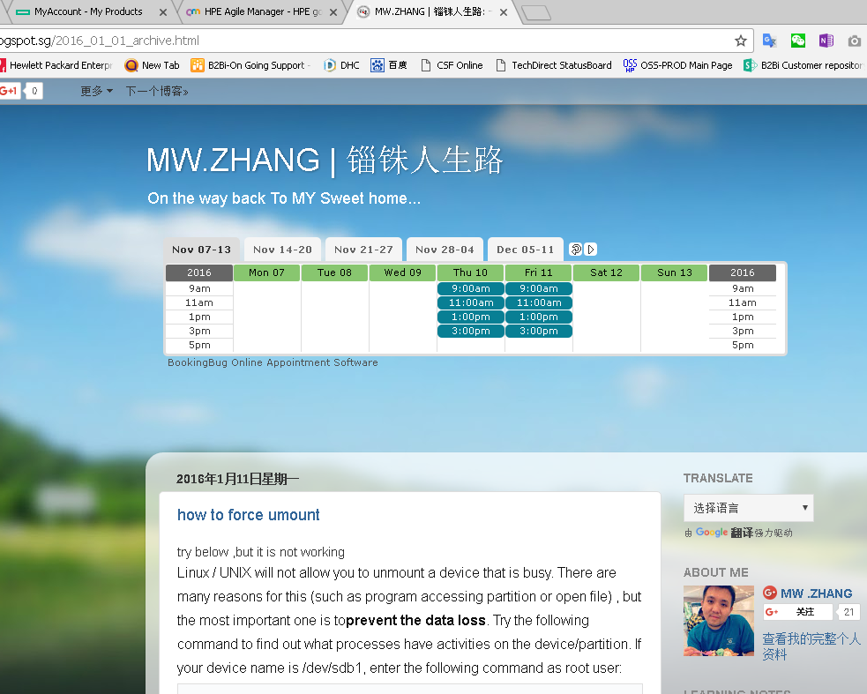

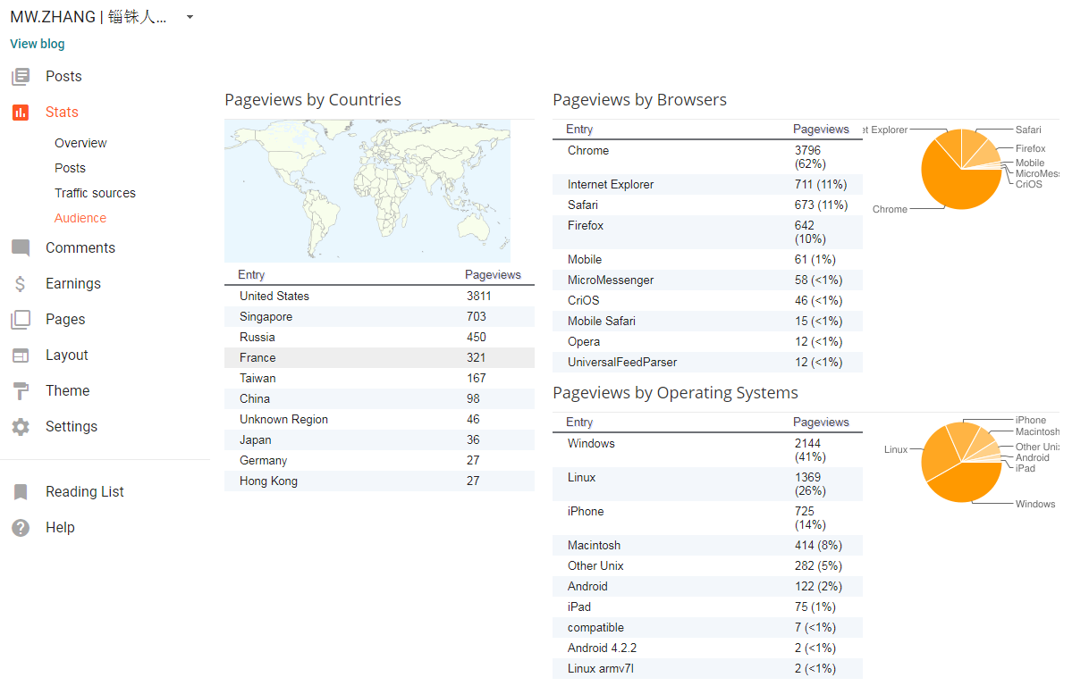

**【AWARD & RECOGNIZATION.】**

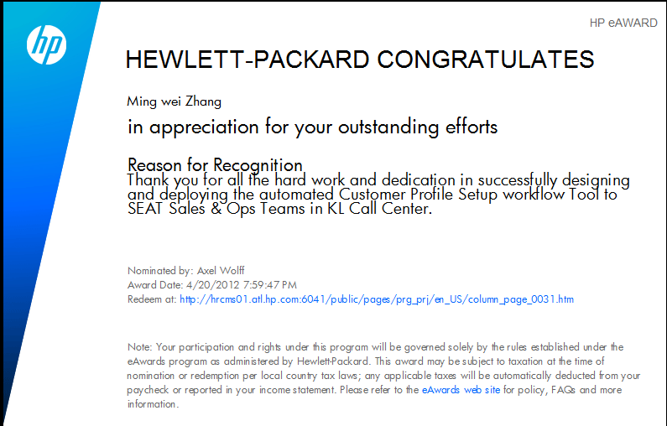

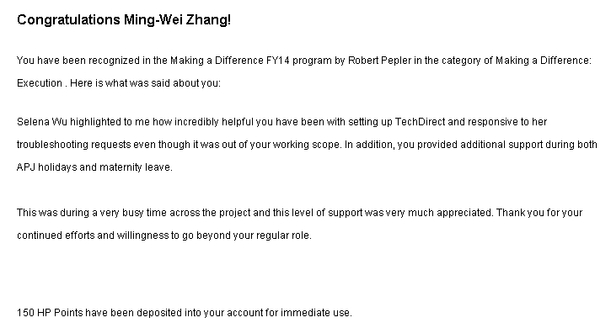

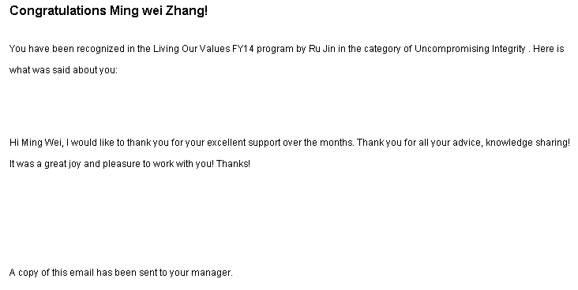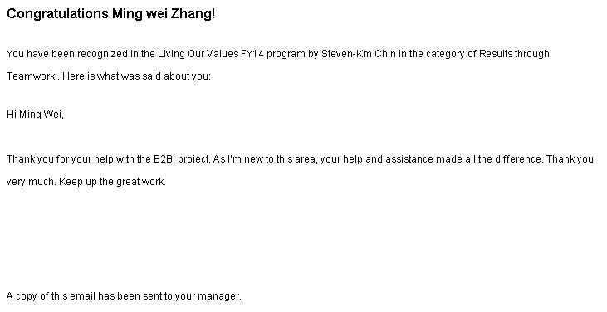

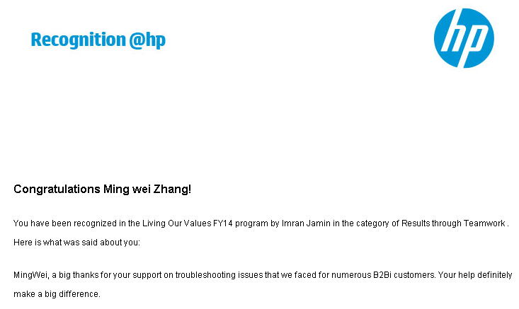

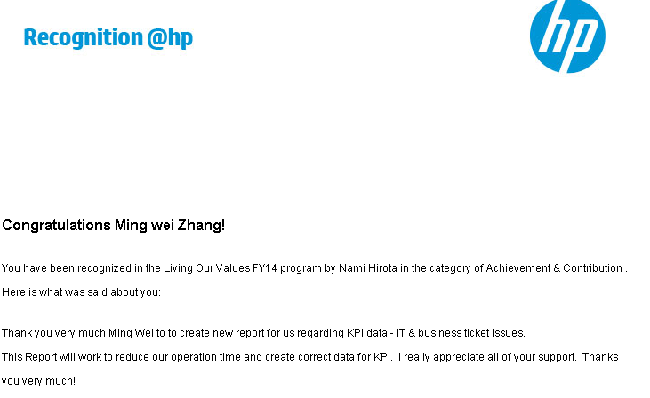

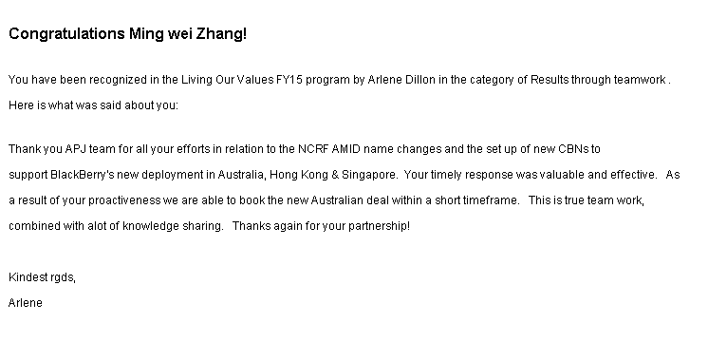

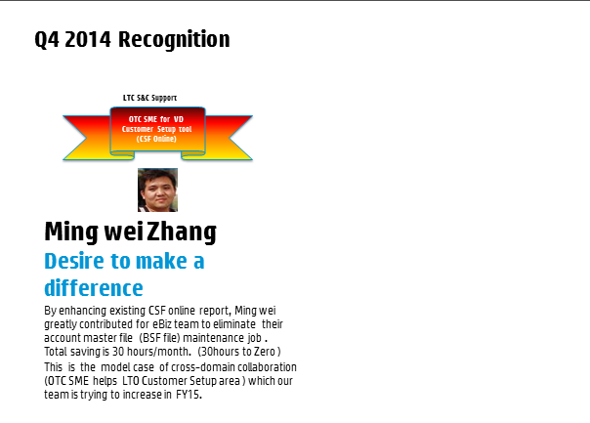

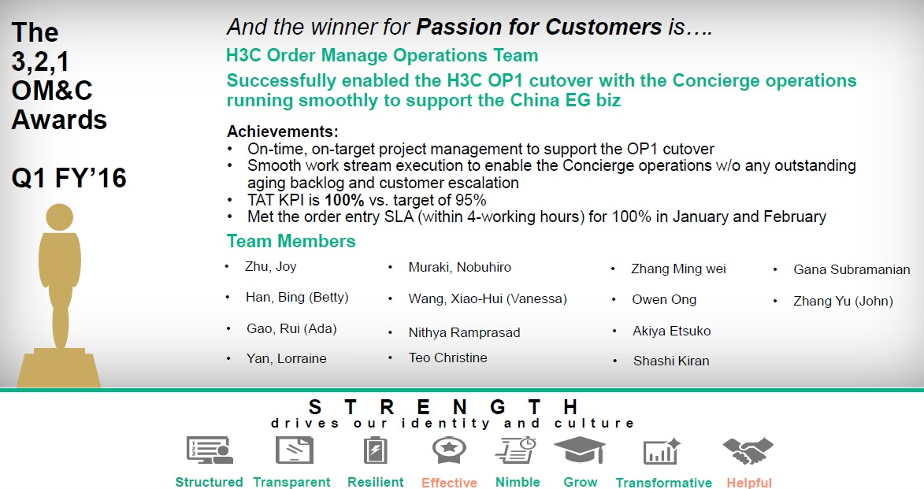

------END FOR NOW------